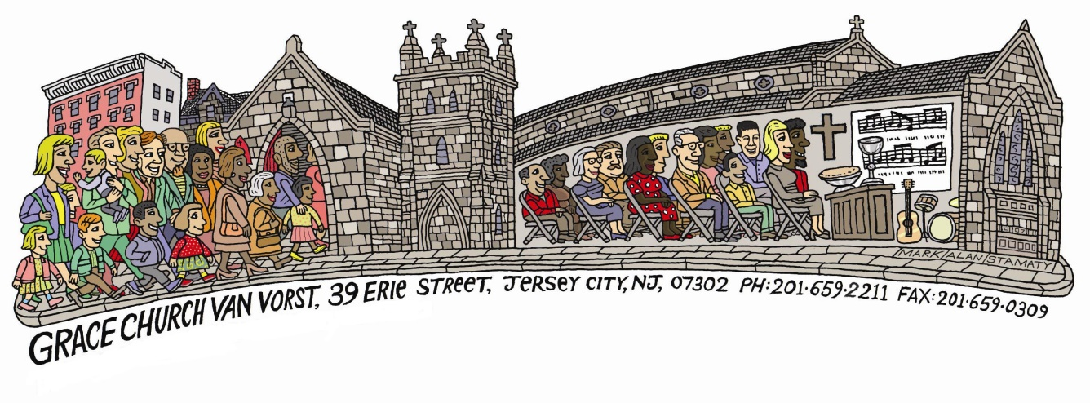
Grace Church Van Vorst
Estimated Giving Form ~ 2020
During this season of thanksgiving, we ask that you thoughtfully and prayerfully consider the reasons you attend worship services and participate in the life of Grace Church Van Vorst, reflecting on the many blessings God has bestowed on you and your loved ones.
As a foundation for your prayer, we recommend that you consider this question: "What portion of my income is God calling me to give?"
We also suggest that those with children make this a family decision, for it is only through our own example of giving that our children are taught the importance of supporting God's work on earth.
My/Our total annual pledge for the 2020 calendar year is: $_________._____
I/We plan to meet this pledge through payments occurring:
____ Weekly ___ Monthly ____ Quarterly ____ All At Once
Name(s): ______________________________________________________________
Address: _______________________________________________________________
Home Phone: _____________________________________________________________
Cell Phone(S): _____________________________________________________________
Email(s):__________________________________________________________________
Signature(s):________________________________________________________________
I/We would live to make our pledge payment(s) through use of credit card:
Card Type (Visa, MC, AMEX, Discover):_______ Ex Mo/Yr:________
Card Number:__________________________________________ CVV:______
Please Indicate Below if you’re interested in any of these topics:
___ Information about making a “Planned Gift” (through an estate or support work)
___ Making a one-time gift to support a special project
Thank you for your generous support of Grace Church Van Vorst & its ministries!

